CONFIGURE THE APPLICATION TO RECEIVE THE DATA

FROM CLOUD

TEAM ID : PNT2022TMID41407

RESOURCE LIST:

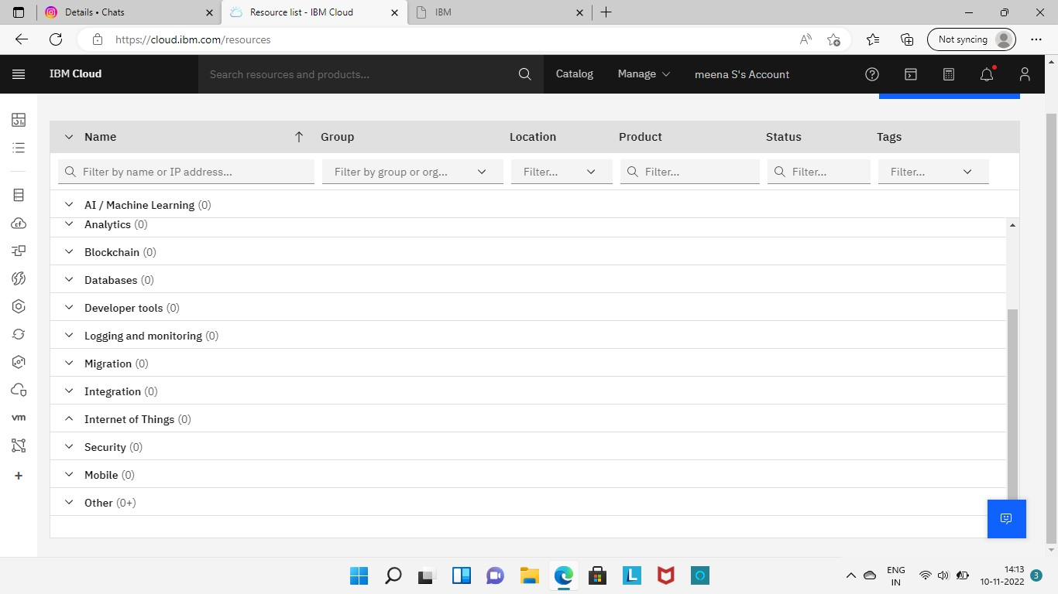

APP DEVELOPMENT:

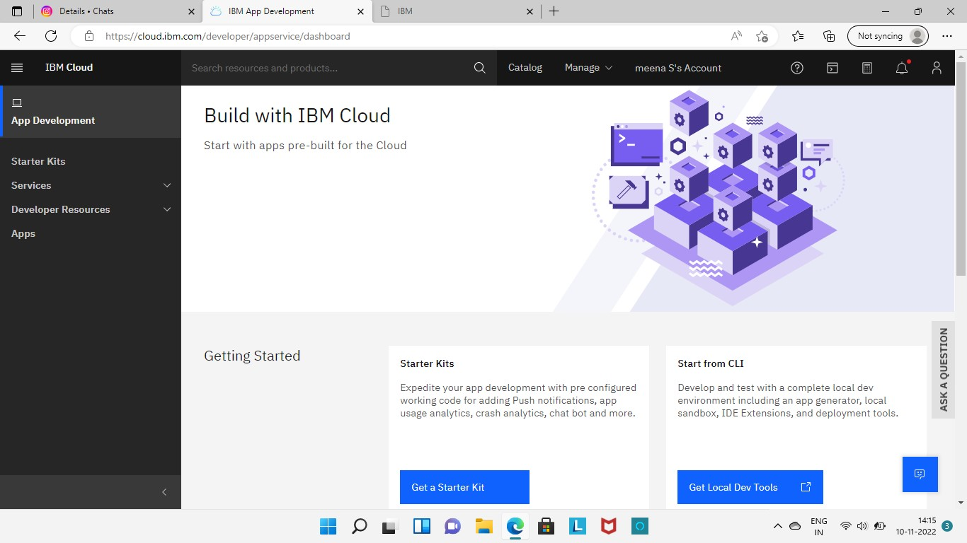

EVALUATION OF RESOURCES:

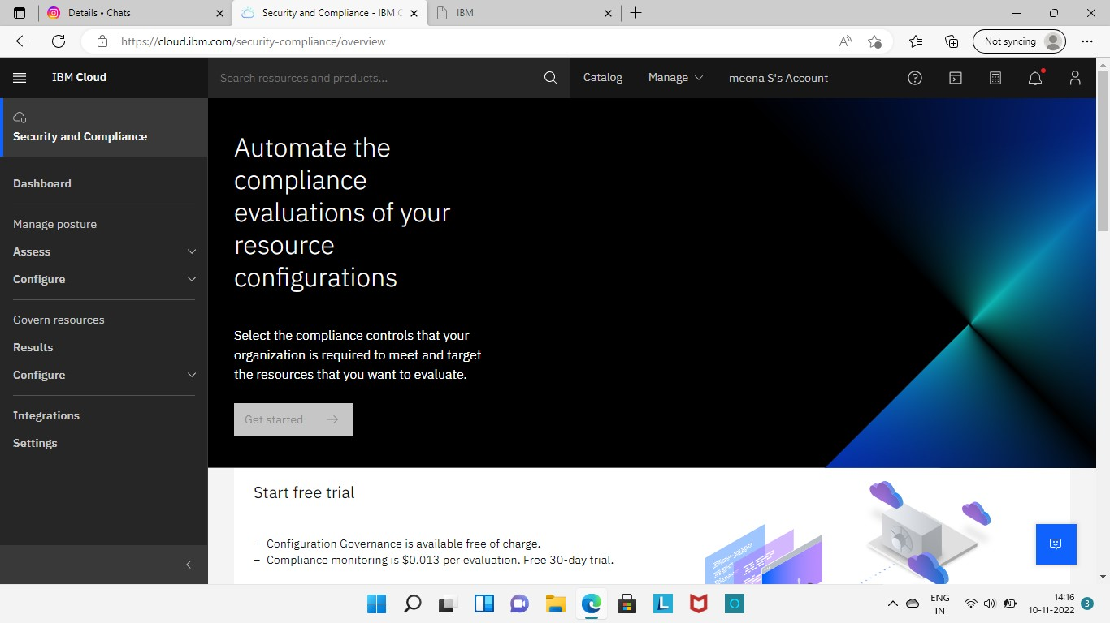

IBM CLOUD’S DEPLOYMENT MANAGER:

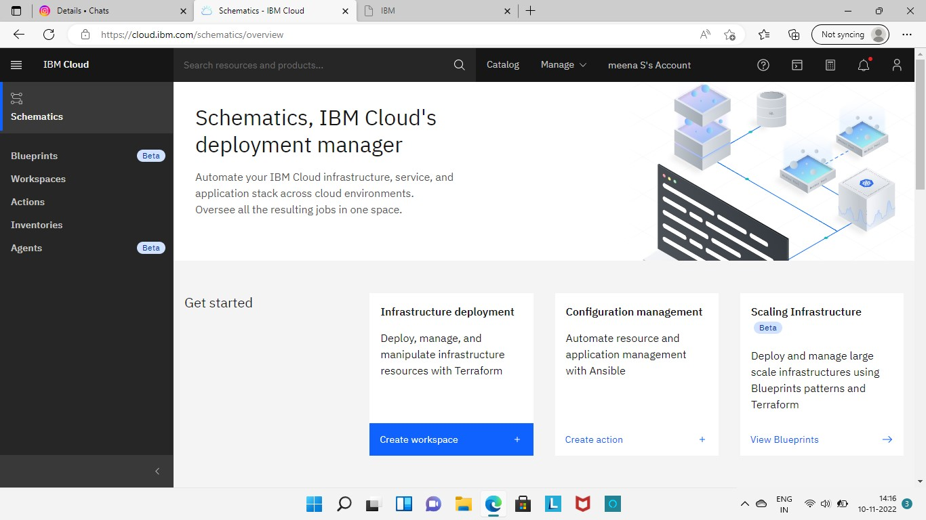

RECEIVE THE DATA FROM CLOUD:

